R23 Full Stack Development–II Lab Manual
1. Introduction to Modern JavaScript and DOM
a. Link JavaScript file with HTML
HTML (index.html):
<!DOCTYPE html> <html>
<head>
<title>Link JS</title> </head>
<body>
<h1 id="welcome">Welcome to My Page</h1> <script src="script.js"></script>
</body> </html>
JavaScript (script.js):
document.getElementById("welcome").style.color = "blue"; Output: 'Welcome to My Page' in blue color.
Execution: Open index.html in your browser.
b. Select HTML elements using selectors
<html> <head>
<title>Selectors Example</title> </head>
<body>
<p id="para">Hello</p>
<p class="text">World</p> <script>
const byId = document.getElementById("para"); const byClass = document.querySelector(".text");

console.log(byId.textContent); // Hello console.log(byClass.textContent); // World
</script> </body> </html>
c. Implement Event Listeners
<!DOCTYPE html> <html>
<head>
<title>Event Listener Example</title> </head>
<body>
<button id="btn">Click Me</button> <script>
document.getElementById("btn").addEventListener("click", () => { alert("Button Clicked!");
}); </script>
</body> </html>
d. Handle click events
<!DOCTYPE html> <html>
<head>
<title>Click Event Example</title> </head>
<body>
<button onclick="handleClick()">Click Me</button> <script>
function handleClick() { alert("Handled Click!");
}
</script> </body> </html>
e. Function declaration, definition, arrow
<!DOCTYPE html>
.

<html> <head>
<title>Function Types Example</title> </head>
<body>
<h2>Check Console for Output</h2> <script>
// Function Declaration function declaredFunction() {
console.log("Declared Function");
}
// Function Expression (Definition) const definedFunction = function () {
console.log("Defined Function"); };
// Arrow Function
const arrowFunction = () => { console.log("Arrow Function");
};
// Call all functions declaredFunction(); definedFunction(); arrowFunction();
</script> </body> </html>
Full Stack Lab Guide: React.js & Node.js (VS Code Setup)
This guide provides installation steps, code examples, execution instructions, and expected
outputs for:
1. Basics of React.js
2. Important Concepts of React.js
3. Introduction to Node.js and Express.js
React.js Setup in VS Code
Step-by-Step Installation
1. Install Node.js from: https://nodejs.org 2. Open VS Code
3. Open Terminal in VS Code: Ctrl + ~ 4. Create a React app:
.

npx create-react-app fsd cd fsd
code .
5. Start development server:
npm start

2. Basics of React.js

Why We Need to Update App.js Every Time
In a React project, the App.js file is like the main screen or controller of your app. Whatever you want to show, change, or add in your application—it usually starts from here.
Think of App.js as the main menu in a restaurant. If you want to add a new dish (like a new component), you need to update the menu so customers can see it.
Explanation:
"App.js is like the heart of your React app. If you create a new feature (like a new button, form,
or page), you need to connect it to App.js—otherwise, your app won’t know about it and it won’t show up on the screen." Finally, App.js is like a stage. If you want a new actor
(component) to appear in the play, you must bring them on stage by adding them in App.js.
a. Counter using Class Component
import React, { Component } from 'react'; class CounterClass extends Component {
constructor() { super();
this.state = { count: 0 };
}
increment = () => {
this.setState({ count: this.state.count + 1 }); };
render() { return ( <div>
<h2>Count: {this.state.count}</h2>

<button onClick={this.increment}>Increment</button> </div>
);
}
}

export default CounterClass;
Update in App.js file
import React from 'react';
import CounterClass from './CounterClass'; // import the component
function App() { return (
<div className="App">
<h1>React Counter Example</h1>
<CounterClass /> {/* Render the class component */} </div>
);
}
export default App;
Output: Displays: Count: 0 and an “Increment” button. Clicking the button increases the count.

Run the Program:
Check whether it is in powershell or cmd, if is powershell then change in to cmd. Execution: npm start
b. Counter using Functional Component
import React, { useState } from 'react'; function CounterFunction() {
const [count, setCount] = useState(0); return (
<div>
<h2>Count: {count}</h2>
<button onClick={() => setCount(count + 1)}>Increment</button> </div>
);
}.

export default CounterFunction;
Update in App.js file
import React from 'react';
import CounterFunction from './CounterFunction'; // import the component
function App() { return (
<div className="App">
<h1>React Function Counter</h1> <CounterFunction />
</div> );
}
export default App;
Output: Displays a counter with button. Each click increments the count.
c. Button Click in Functional Component
function ClickEvent() {
const handleClick = () => alert("Button Clicked!");
return <button onClick={handleClick}>Click Me</button>;
}
export default ClickEvent;
Update in App.js file
import React from 'react';
import ClickEvent from './ClickEvent'; // Import your component
function App() { return (
<div className="App">
<h1>React Click Event Example</h1> <ClickEvent /> {/* Use the component */}
</div> );
}
export default App;

Output: A button that shows an alert “Button Clicked!” when clicked.
d. Conditional Rendering
function ConditionalRender({ isLoggedIn }) {
return <div>{isLoggedIn ? "Welcome!" : "Please log in."}</div>;
}
export default ConditionalRender;
Update in App.js file
import React from 'react';
import ConditionalRender from './ConditionalRender'; // function App() {
return (
<div className="App">
<h1>Conditional Rendering Example</h1>
{/* Case 1: Logged in */} <ConditionalRender isLoggedIn={true} />
{/* Case 2: Not logged in */} <ConditionalRender isLoggedIn={false} />
</div> );
}
export default App;
Output: Displays “Welcome!” if isLoggedIn = true, otherwise “Please log in.”
e. Display Text using String Literals
function Greeting() {
const name = " Mokshith";
return <h1>{`Hello, ${name}!`}</h1>;
}
export default Greeting;
Update in App.js file
import React from 'react';
.

import Greeting from './Greeting'; function App() {
return (
<div className="App">
<h2>Greeting Component Example</h2> <Greeting />
</div> );
}
export default App;
Output: Displays: Hello, Mokshith

3. Important Concepts of React.js
a. Counter using useState
// ClickCounter.js
import React, { useState } from 'react'; function ClickCounter() {
const [count, setCount] = useState(0); return (
<button onClick={() => setCount(count + 1)}> Clicked {count} times
</button> );
}
export default ClickCounter;
Update in App.js file
// App.js
import React from 'react';
import ClickCounter from './ClickCounter';
.

function App() { return (
<div className="App"> <h2>React Click Counter</h2> <ClickCounter />
</div> );
}
export default App;
Output: Displays a button that shows the count and increments on click.
b. Fetch data using useEffect
function FetchData() {
const [posts, setPosts] = useState([]); useEffect(() => {
fetch('https://jsonplaceholder.typicode.com/posts')
.then(res => res.json())
.then(setPosts); }, []);
return ( <ul>
{posts.slice(0, 5).map(post => (
<li key={post.id}>{post.title}</li> ))}
</ul>
);
}
export default FetchData;
Update in App.js file
// App.js
import React from 'react';
import FetchData from './FetchData';
function App() { return (
<div className="App"> <h1>Data Fetch Example</h1> <FetchData />

</div> );
}

export default App;
Output: Displays the titles of the first 5 posts from JSONPlaceholder API.
c. Props Sharing Between Components
function Parent() {
return <Child message="Hello from parent" />;
}
function Child({ message }) { return <p>{message}</p>;
}
export default Parent;
Update in App.js file
// App.js
import React from 'react'; import Parent from './Parent'; // function App() {
return (
<div className="App"> <h1>Props Example</h1> <Parent />
</div> );
}
export default App;
Output: Displays the text: Hello from parent
d. Forms in React
function FormExample() {
const [input, setInput] = useState(""); const handleSubmit = e => {
e.preventDefault();
alert(`Submitted: ${input}`); };

return (
<form onSubmit={handleSubmit}>
<input value={input} onChange={e => setInput(e.target.value)} /> <button type="submit">Submit</button>
</form>
);
}

export default FormExample;
Update in App.js file
// App.js
import React from 'react';
import FormExample from './FormExample'; //
function App() { return (
<div className="App">
<h2>Form Handling Example</h2> <FormExample />
</div> );
}
export default App;
Output: Takes user input. On submit, shows alert: Submitted: <input>
e. Iterative Rendering using map()
function TechList() {
const techs = ["React", "Node", "Express"]; return (
<ul>
{techs.map((tech, index) => <li key={index}>{tech}</li>)} </ul>
);
}
export default TechList;
Update in App.js file
// App.js

import React from 'react';
import TechList from './TechList'; //
function App() { return (
<div className="App">
<h1>React List Rendering Example</h1> <TechList />
</div> );
}
export default App; Output: Displays:
• React• Node
• Express
Node.js + Express Setup in VS Code Step-by-Step Installation
1. Install Node.js
Create a folder: mkdir fsdexpress
2. Next to change the folder
cd fsdexpress
3. Initialize app:
npm init -y
npm install express
4. Create file: app.js
4. Introduction to Node.js and Express.js
Steps to follow:
Create app.js in Your Folder (which you created using mkdir command)
In VS Code:
.

• Open your project folder (fsdexpress)• Create a new file: app.js
• Paste the following basic Hello World code:
a. Hello World
const express = require('express'); const app = express();
const port = 3000;
app.get('/', (req, res) => {
res.send('Hello World from Express!'); });
app.listen(port, () => {
console.log(`Server is running at http://localhost:${port}`); });

Run the Program
In the VS Code terminal (View > Terminal) or regular command prompt:
node app.js
Open in Browser and Visit:
http://localhost:3000
Hello World from Express!
Output: Visit http://localhost:3000→Shows Hello World from Express!

b. Multiple Routes
Update app.js file with the following code:
const express = require('express'); const app = express();
const port = 3000;
app.get('/', (req, res) => {
res.send('Welcome to the Home Page!'); });
app.get('/about', (req, res) => { res.send('About Us Page');
});

app.get('/contact', (req, res) => { res.send('Contact Us Page');
});
app.listen(port, () => {
console.log(`Server running at http://localhost:${port}`); });

Run the Program
In the VS Code terminal (View > Terminal) or regular command prompt:
node app.js
Open in Browser and Visit:
http://localhost:3000 Welcome to the Home Page
Output: Visit http://localhost:3000→Shows Welcome to the Home Page

c. Print Hello World in Console
Update app.js file with the following code:
const express = require('express'); const app = express();
const port = 3000;
app.use(express.static('public')); app.listen(port, () => {
console.log(`Server running at http://localhost:${port}`); });

How to Create public/index.html in VS Code
Step 1: Inside your project folder(fsdexpress), create a folder named public
• Right-click in VS Code Explorer
• Click New Folder→name it public
Step 2: Inside public, create a file called index.html• Right-click on public folder
• Click New File→name it index.html
.

Step 3: Paste this code in index.html
Step 3: Confirm index.html contains this
<!DOCTYPE html> <html>
<head>
<title>Hello Console</title> <script>
console.log("Hello World from Browser Console using Express.js"); </script>
</head> <body>
<h1>Open the browser console to see the message</h1> </body>
</html>
Run the Program
In the VS Code terminal (View > Terminal) or regular command prompt:
node app.js
Open in Browser and Visit:
http://localhost:3000
Now press:
• F12 or
• Right-click→Inspect→Console tab
You should now see:
Output: Hello World from Browser Console using Express.js
d. CRUD with Express
Create a crud.js file with the following code:
const express = require('express'); const path = require('path');
const app = express(); const port = 3000;
let students = [
{ id: 1, name: 'Mokshith' }, { id: 2, name: 'Vaman' }
.

];
app.use(express.json());
app.use(express.static('public')); // serve index.html
// API Routes
app.get('/api/students', (req, res) => { res.json(students);
});
app.post('/api/students', (req, res) => { const student = req.body;
students.push(student);
res.status(201).json({ message: 'Student added', student }); });
app.put('/api/students/:id', (req, res) => { const id = parseInt(req.params.id); const updatedStudent = req.body;
students = students.map(s => s.id === id ? updatedStudent : s); res.json({ message: 'Student updated' });
});
app.delete('/api/students/:id', (req, res) => { const id = parseInt(req.params.id); students = students.filter(s => s.id !== id); res.json({ message: 'Student deleted' });
});
app.listen(port, () => {
console.log(`Server running at http://localhost:${port}`); });

Update public/index.html file with the following code:
<!DOCTYPE html> <html>
<head>
<title>Student CRUD</title> </head>
<body>
<h1>Student Management</h1>
.

<h3>Add Student</h3>
<input type="number" id="id" placeholder="ID" /> <input type="text" id="name" placeholder="Name" /> <button onclick="addStudent()">Add</button>
<h3>Update Student</h3>
<input type="number" id="updateId" placeholder="ID to Update" /> <input type="text" id="updateName" placeholder="New Name" /> <button onclick="updateStudent()">Update</button>
<h3>Delete Student</h3>
<input type="number" id="deleteId" placeholder="ID to Delete" /> <button onclick="deleteStudent()">Delete</button>
<h3>All Students</h3>
<button onclick="loadStudents()">Load Students</button> <ul id="studentList"></ul>
<script>
function loadStudents() { fetch('/api/students')
.then(res => res.json())
.then(data => {
const list = document.getElementById('studentList'); list.innerHTML = '';
data.forEach(student => {
const li = document.createElement('li');
li.textContent = `${student.id}: ${student.name}`; list.appendChild(li);
});
});
}
function addStudent() {
const id = parseInt(document.getElementById('id').value); const name = document.getElementById('name').value;
fetch('/api/students', { method: 'POST',
headers: { 'Content-Type': 'application/json' }, body: JSON.stringify({ id, name })
})
.then(res => res.json())
.then(() => loadStudents());

}
function updateStudent() {
const id = parseInt(document.getElementById('updateId').value); const name = document.getElementById('updateName').value;
fetch(`/api/students/${id}`, { method: 'PUT',
headers: { 'Content-Type': 'application/json' }, body: JSON.stringify({ id, name })
})
.then(res => res.json())
.then(() => loadStudents());
}
function deleteStudent() {
const id = parseInt(document.getElementById('deleteId').value);
fetch(`/api/students/${id}`, { method: 'DELETE'
})
.then(res => res.json())
.then(() => loadStudents());
}
</script> </body> </html>
Output: In the browser:

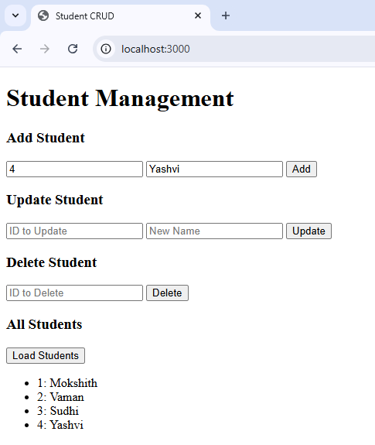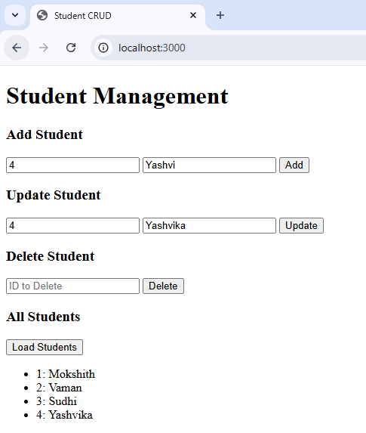

Add Update

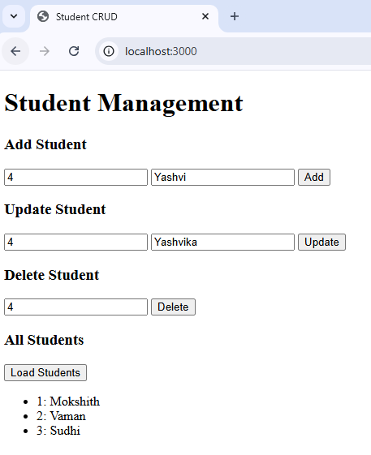

Delete
f. Connect Express to MySQL

.

const express = require('express'); const mysql = require('mysql'); const app = express();
const db = mysql.createConnection({ host: "localhost",
user: "root", password: "", database: "testdb"
});
db.connect(err => { if (err) throw err;
console.log("Connected to MySQL"); });
app.get('/', (req, res) => {
db.query("SELECT * FROM users", (err, results) => { if (err) throw err;
res.json(results); });
});
app.listen(3000);
Output:

id | name | email
1 | Mokshith | M@example.com
2 | Sudhi | S@example.com

.

